🌐 How to Link the Static Library (.a) to a STM32CubeIDE Project
The LCD panel static graphic libraries (.a) are located within the KVB_LCD project folder, alongside the GUI and evaluation files (.c and .h).
📂 File Structure Overview
- KVB_LCD.h – Main GUI (Graphical User Interface) header file.
- KVB_TEST.h – Header file containing two evaluation/presentation functions tailored for different screen resolutions.
- KVB_TEST.c – Source file implementing the two resolution-dependent evaluation functions.
- KVB_TEXT.h – Header file dedicated to the text variables used in the evaluation code.
- KVB_TEXT.c – Source file containing the text variable definitions for the evaluation code.
- libLCD_16bit_Open407_F407VGT6_9325.a – Static library file for the ILI9325 LCD panel (320 x 240 resolution).
- libLCD_16bit_Open407_F407VGT6_9341.a – Static library file for the ILI9341 LCD panel (320 x 240 resolution).
- libLCD_16bit_Open407_F407VGT6_9481.a – Static library file for the ILI9481 LCD panel (480 x 320 resolution).
- libLCD_16bit_Open407_F407VGT6_9486.a – Static library file for the ILI9486 LCD panel (480 x 320 resolution).
- libLCD_16bit_Open407_F407VGT6_8009A.a – Static library file for the OTM8009A LCD panel (800 x 480 resolution).

⚙️ Linker and GUI Configuration Steps
- In the Project Explorer panel, right-click the root of your project folder and navigate to Properties -> C/C++ Build -> Settings, then open the Tool Settings tab.
- Scroll down to the MCU GCC Linker section and click on the Libraries sub-item.
- You will see two configuration windows: Libraries (-l) (the upper window) and Library search path (-L) (the lower window).
- In the lower window (Library search path -L), add the path to the directory where your physical library file (e.g., libLCD_16bit_Open407_F407VGT6_9486.a) resides.
- In the upper window (Libraries (-l)), add your library's name. CRITICAL REQUIREMENT: You must input the name strictly WITHOUT the lib prefix and WITHOUT the .a extension (for example, type exactly: LCD_16bit_Open407_F407VGT6_9486). Note: Only one graphic library must be added to the project configuration at a time.
- Click Apply and Close.
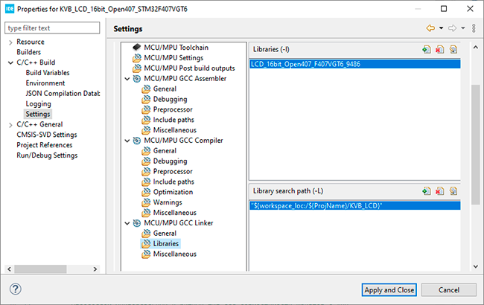
- Open the main GUI header file KVB_LCD.h, locate line 120, and uncomment strictly the line corresponding to your target LCD panel. This line contains the averaged timing configuration for the panel's FSMC bus. These values depend heavily on the specific hardware implementation of the panel, wire lengths, and ribbon cable traits.
⚠️ CRITICAL HARDWARE NOTE: Due to the extremely high data transfer rates into the display's GRAM, if you are using a flat ribbon cable, it is MANDATORY to install a 22 pF signal reflection dampening capacitor at the very end of the ribbon cable. Place it as close as physically possible to the panel's interface connector on the WE (Write Enable) signal line.
- Finally, navigate to your project's main.c file and uncomment one of the two evaluation functions depending on your display's resolution: lcd_Test480x320Landscape() or lcd_Test320x240Landscape().
During the compilation process, STM32CubeIDE will automatically fetch and link the pre-compiled binary code from your specified library file (e.g., libLCD_16bit_Open407_F407VGT6_9486.a).

